In this chapter we will explore some of the Seaside from the web browser’s point of view, including examples available with the default installation of Seaside.

1. Launch your Seaside image (see Chapter 1 for details) and open a web browser on <http://localhost:8080/browse>.

This page gives a list of the applications that have been registered with Seaside through the WADispatcher singleton (available by evaluating the Smalltalk expression ‘WADispatcher default’). The dispatcher looks at the URL requested, and dispatches the request to one of these registered entry points. This is how the request from the client browser gets to the appropriate Smalltalk code (such as our ‘HelloWorld’ application).

1. Click on the config link to see the ‘Dispatcher Editor.’ This tool sets up the information for the Dispatcher Viewer we saw above.Graphical user interface, application, website

   Description automatically generated

The left column lists each of the entry points and the initial selection is the root, which is just a dispatcher to some other web component. There are various types of components, including other dispatchers (examples/, javascript/, tests/, and tools/), applications (browse, config, hello, status, and welcome), a file library (files), and a legacy redirection (seaside). Selecting any component in the left column gives you some configuration information about that component.

Note that there is a star next to the *default* component. The default component is the one provided by Seaside if you select the root (e.g., <http://localhost:8080/>). In chapter 2, step 13, we clicked ‘Yes’ when Seaside offered to change the default application from ‘welcome’ to ‘browse’.

Note that near the top of the config page there is a ‘Clear Default’ button. Click the button then open a new web browser (window or tab) and navigate to the root. You should get an error.

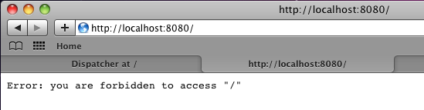

Switch back to the config page (at <http://localhost:8080/config> if you did not save that page), select ‘hello’ from the links on the left, and then click the ‘Set Default’ button. This will make our Hello World application the default Seaside application.

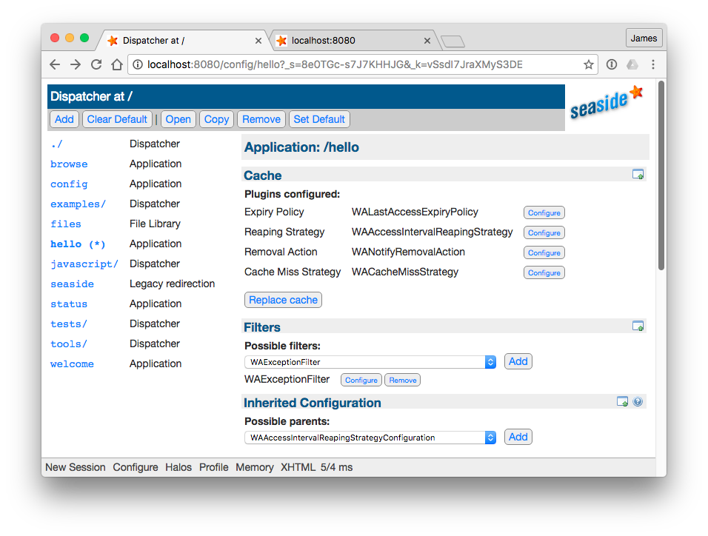

In your web browser, switch back to the tab or window with the error and refresh (or enter <http://localhost:8080/>). You should now see our Hello World application at the root.

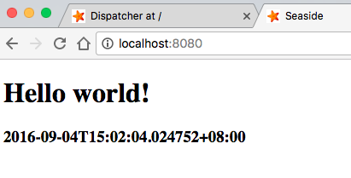

The config page provides a great deal of other configuration capabilities and demonstrates some of the capabilities of a Seaside component. We will not examine this area further at this time.

1. Enter <http://localhost:8080/browse> to return to the list of components and select ‘Status’ (or enter <http://localhost:8080/status> in your web browser’s address bar). This will show you a list of tabs containing information about your Smalltalk environment. The first tab identifies the location of the file containing a snapshot (image) of the object space when it was last saved to disk. It also gives you the opportunity to make another snapshot of the current object space (by saving the image).

The ‘Seaside’ tab identifies the version of Seaside installed and lists the version of various installed packages.

1. Return to <http://localhost:8080/browse> and select ‘examples’ (a directory of other entry points). You should see the following:

Click on the ‘counter’ and you will see the traditional Seaside example of an application that keeps state on the server. We will be using a slightly more complex example to explore some Seaside basics.

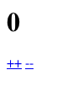

You may save and quit or go on to the next chapter.